ESD Lab 3

Mehul Patel

Org : University of Colorado Boulder

ECEN 5613 Embedded System Design

* All Conneciton are done as per Schematic

SPLD

**ATMEL F16V8C - SPLD connections -**

**SPLD input**

* Pin 2 SPLD – mcu A15
* Pin 6 SPLD – mcu RD
* Pin 8 SPLD – mcu PSEN
* Pin 9 SPLD – mcu WR

**SPLD output**

* PIN 12 = oe bar of NVRAM
* PIN 13 = CE BAR OF NVRAM
* PIN 14 = we bar of nvram

/* *************** INPUT PINS *********************/

PIN 2 = A15 ; /* Pin 2 SPLD - mcua15 */

PIN 6 = RD ; /* Pin 6 SPLD - mcua rd */

PIN 8 = PSEN ; /* Pin 8 SPLD - mcua PSEN */

PIN 9 = WR ; ; /* Pin 9 SPLD - mcua WR */

/* *************** OUTPUT PINS *********************/

PIN 12 = READ ; /*oe bar of NVRAM */

PIN 13 = CSPERIPH ; /*CE BAR OF NVRAM*/

PIN 14 = WRBAR; /*we bar of nvram*/

/* *************** LOGIC *********************/

READ = RD & PSEN; /*oe bar of NVRAM */

CSPERIPH = A15; /*CE BAR OF NVRAM*/

WRBAR = (WR # A15); /*we bar of NVRAM*/

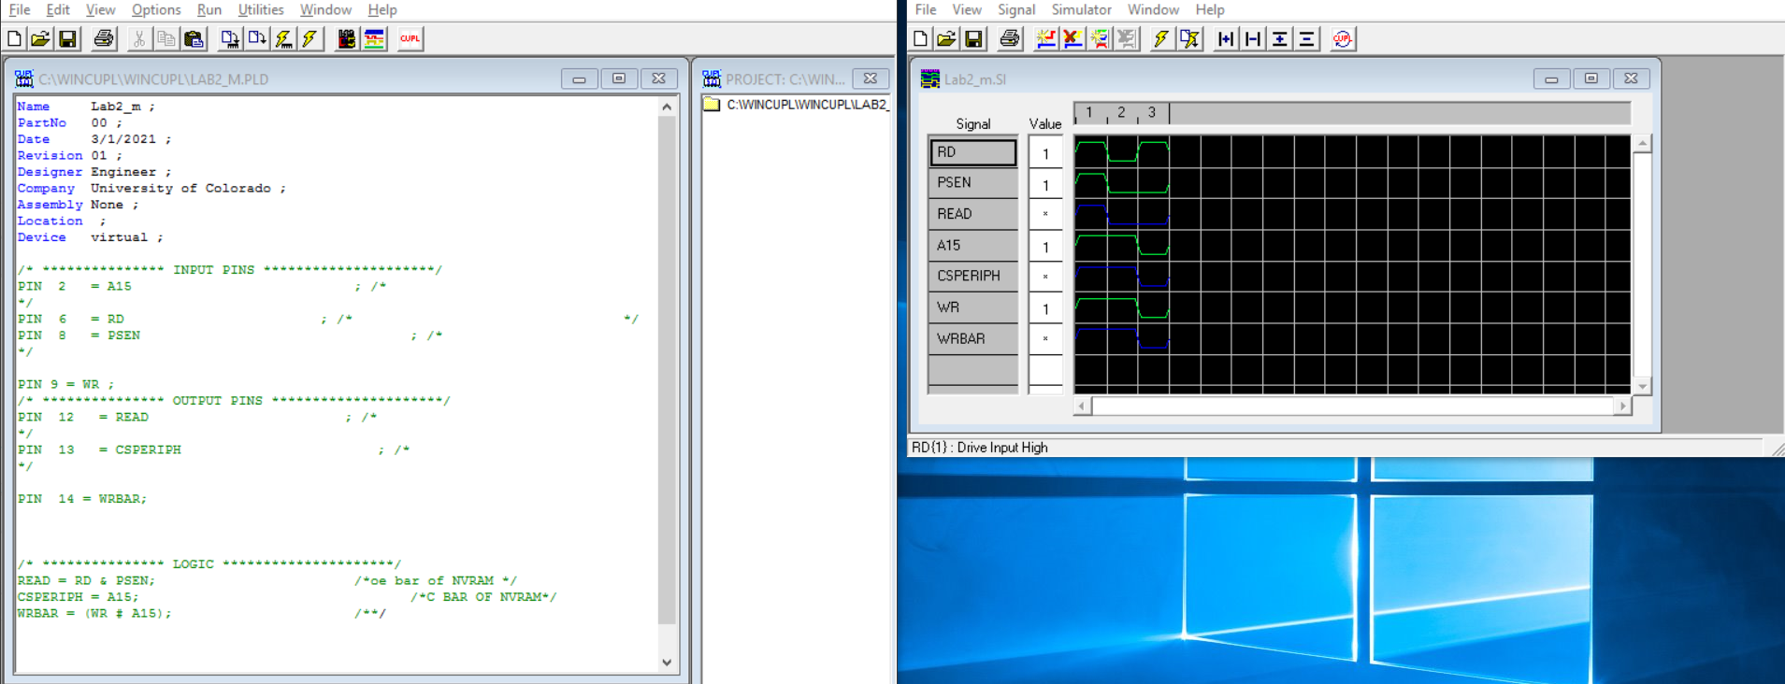

Paulman data writing

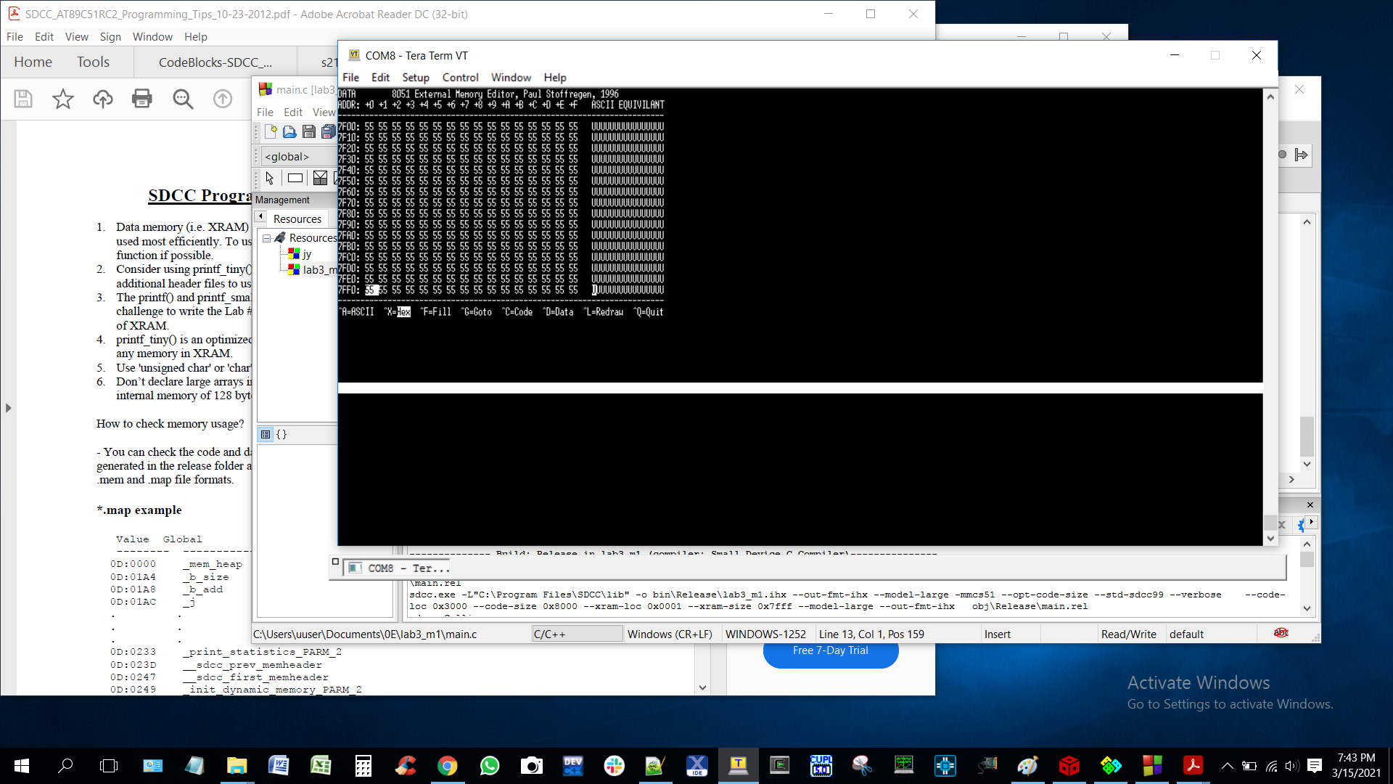

Loading code

start from 0x3000 loc

sdcc settigns

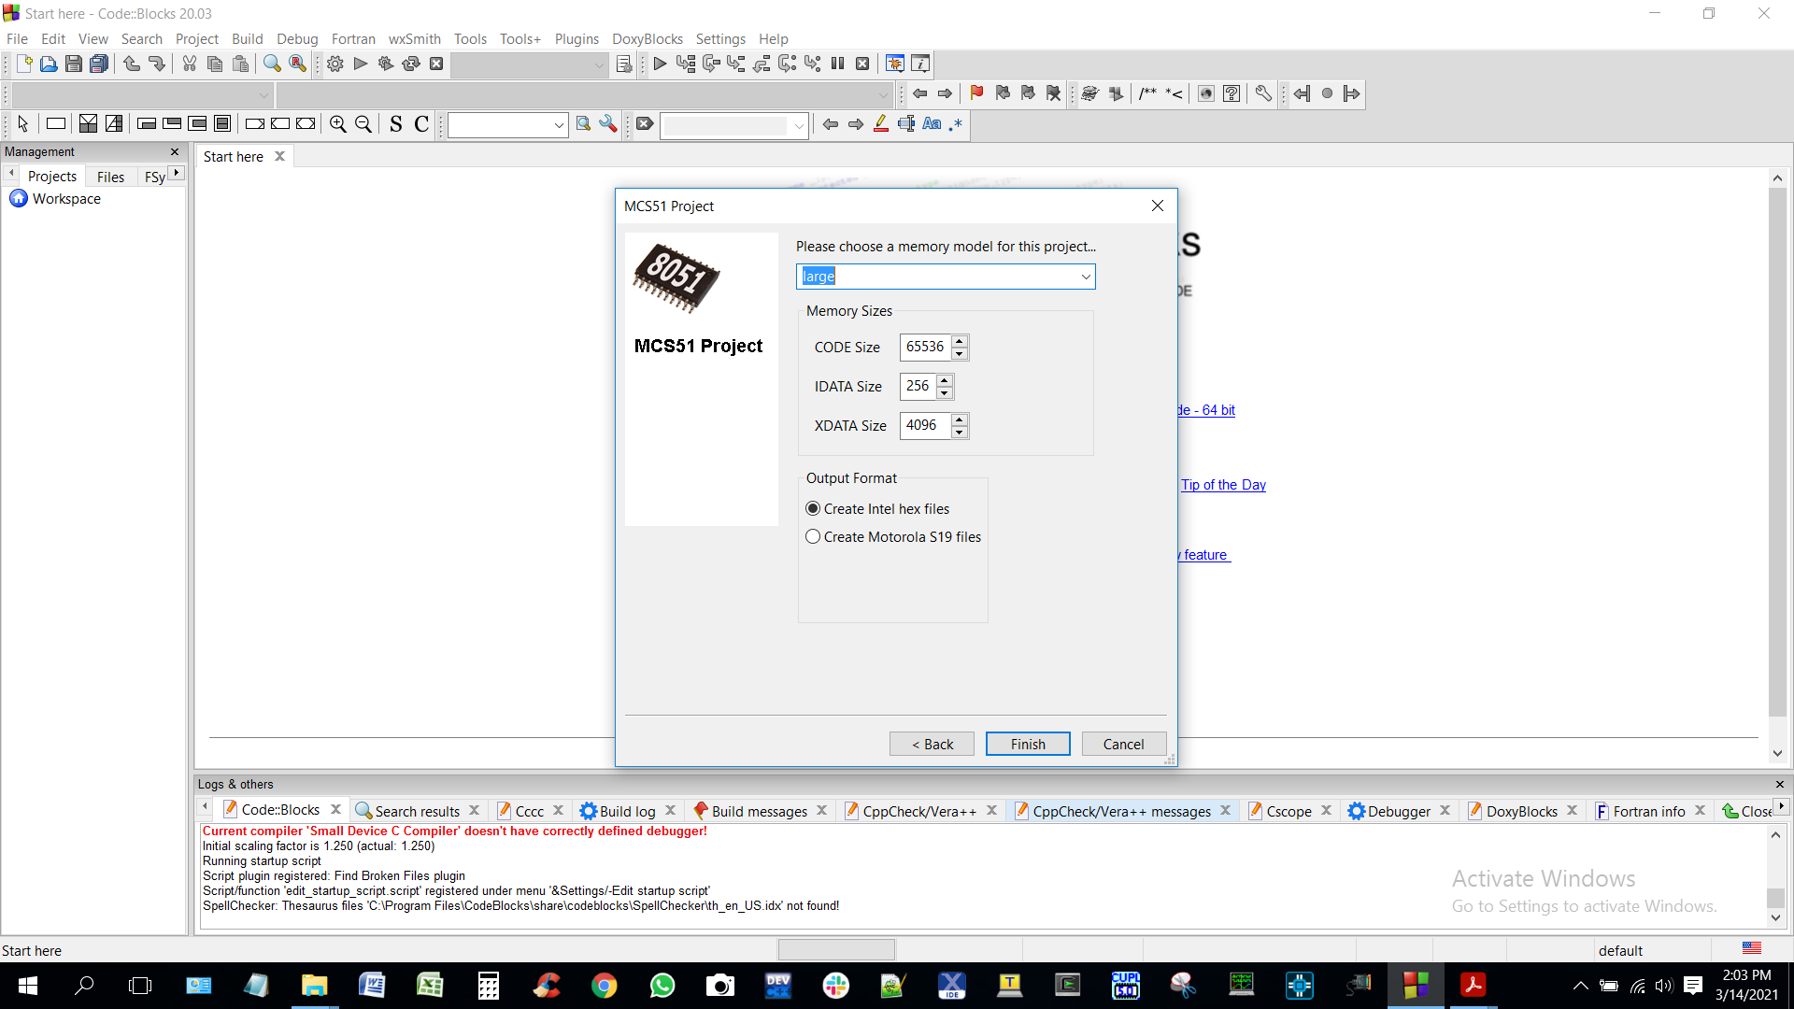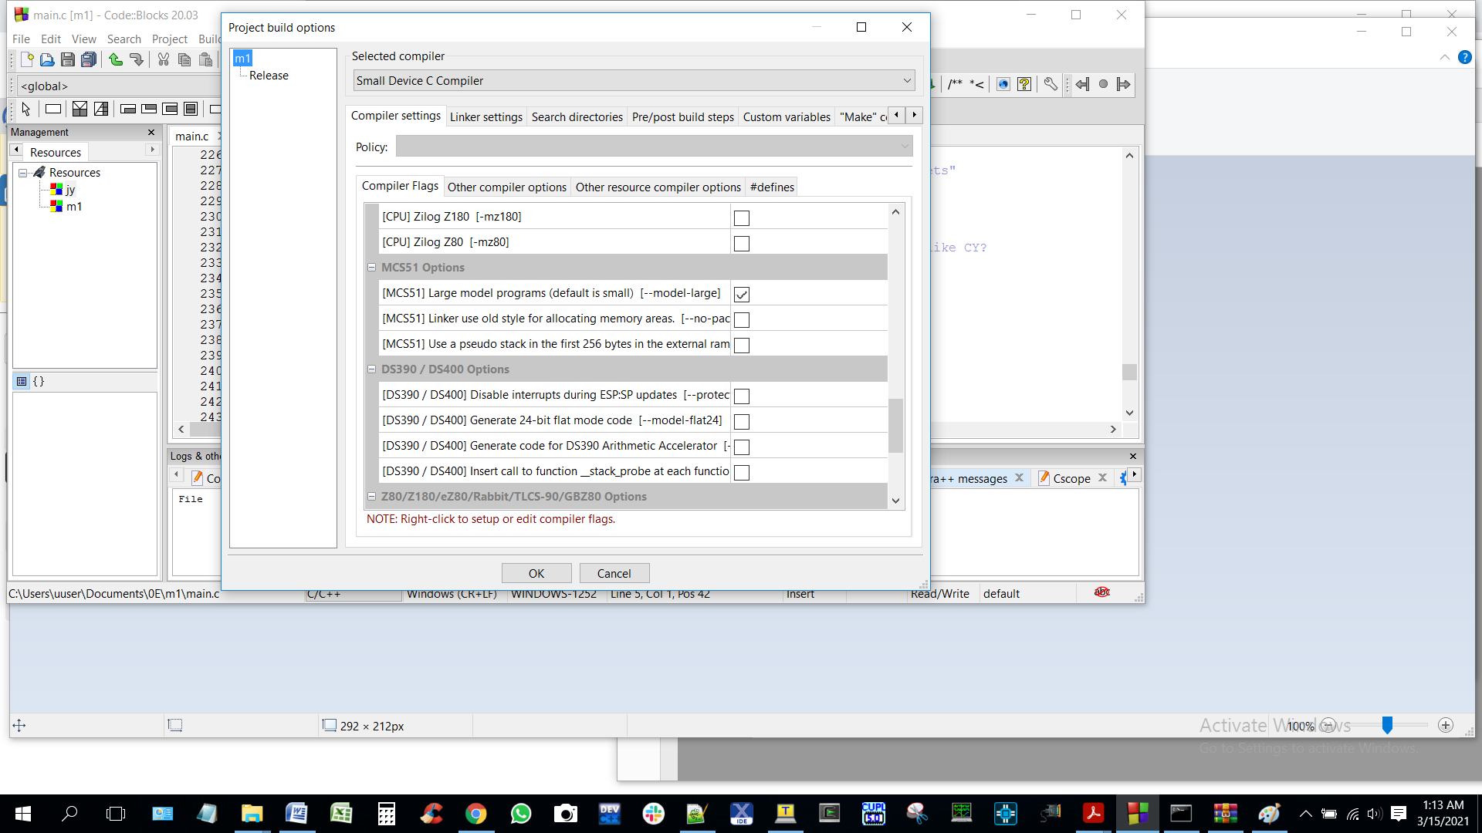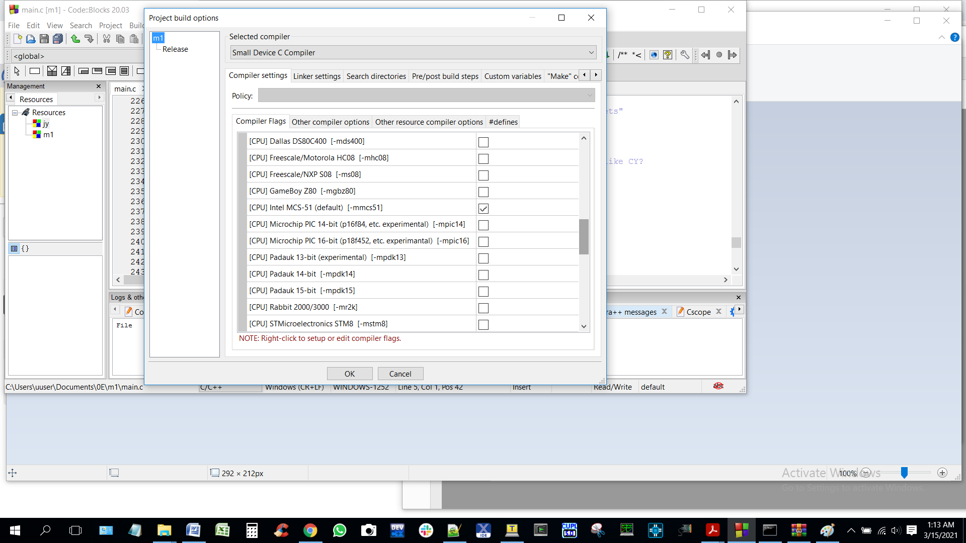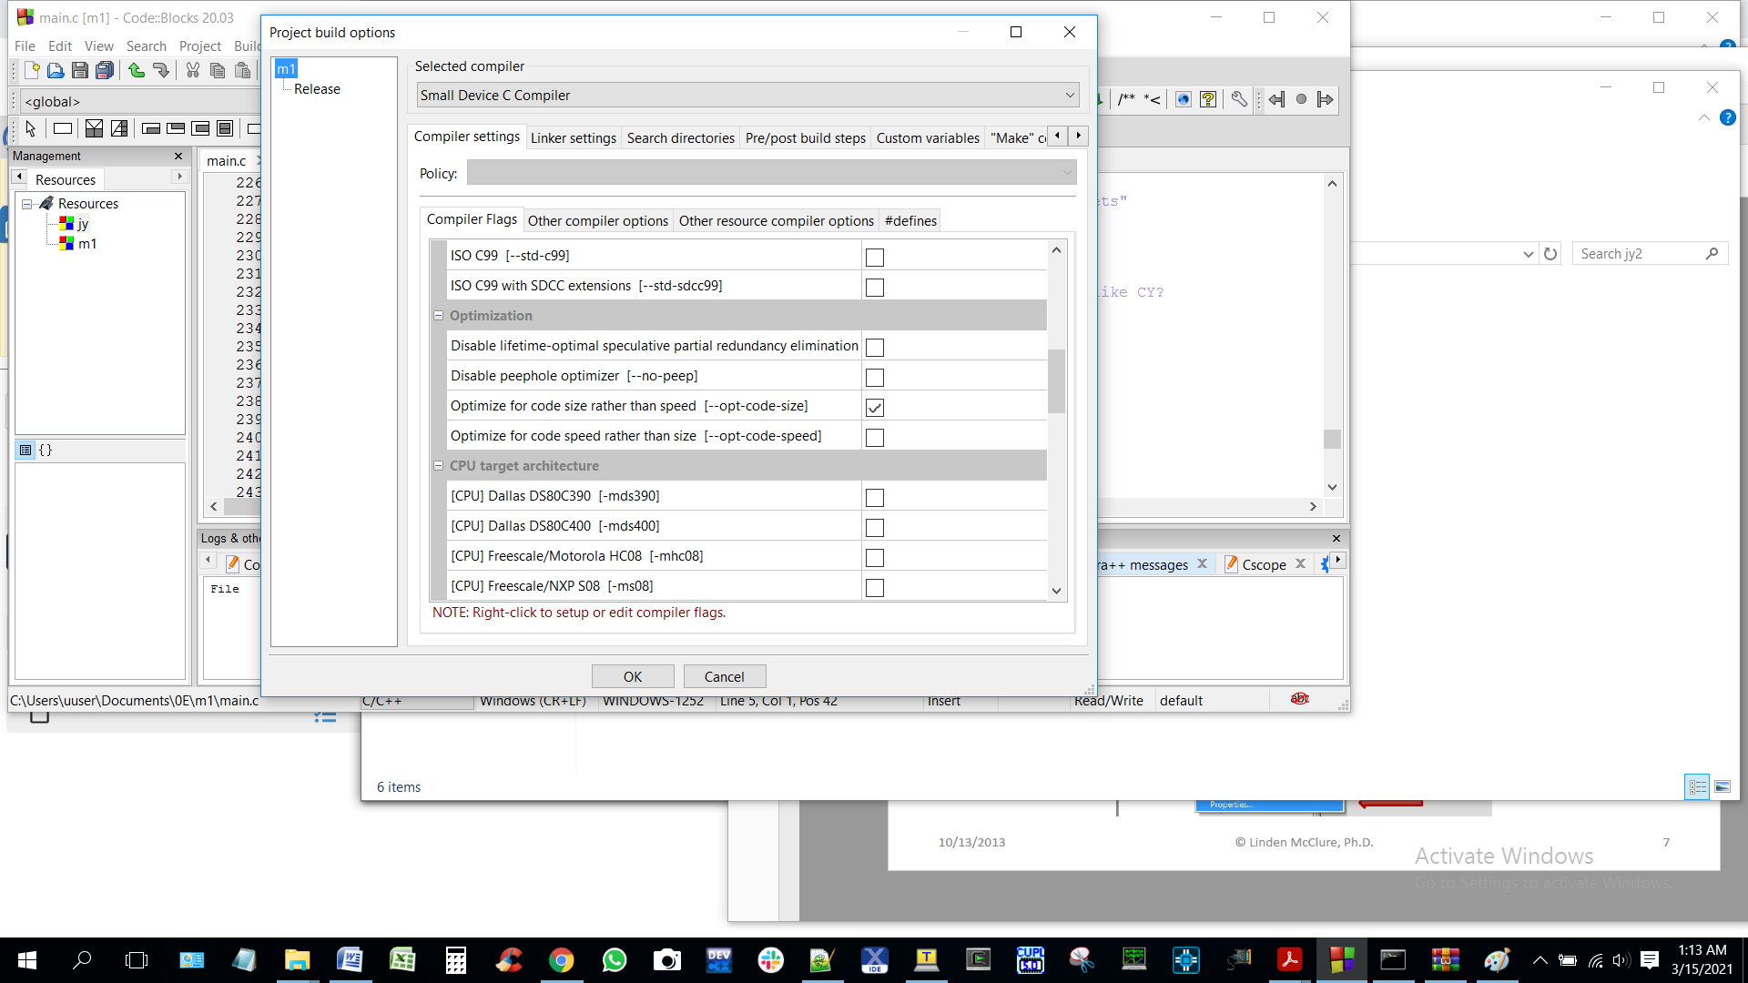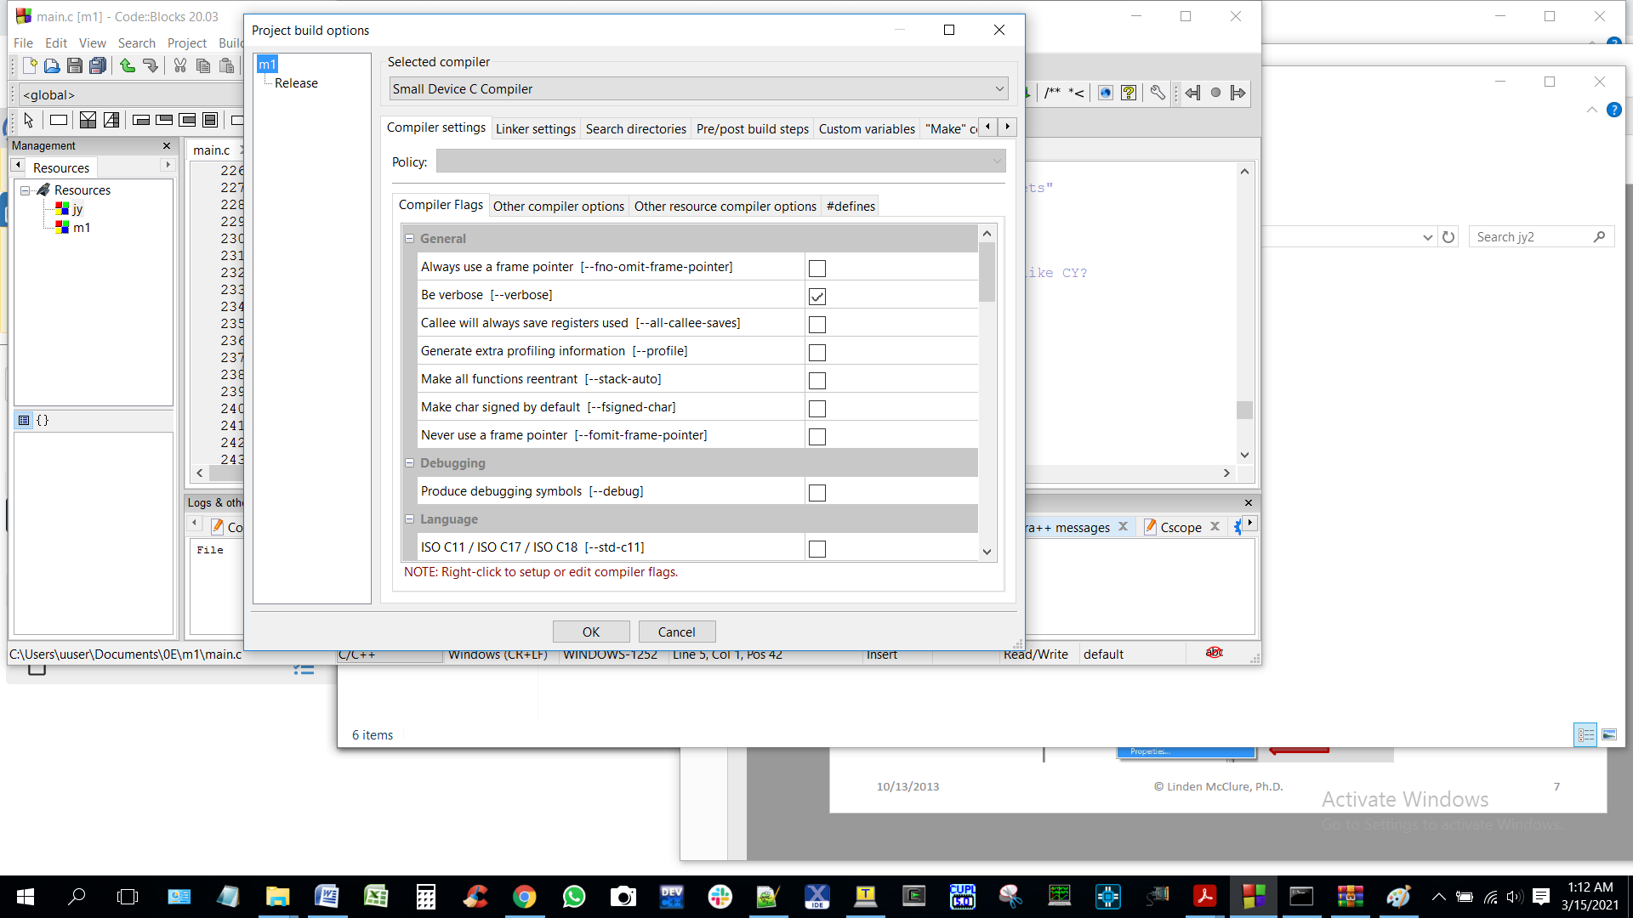

--code-loc 0x3000 --code-size 0x8000 --xram-loc 0x0001 --xram-size 0x7fff --model-large --out-fmt-ihx

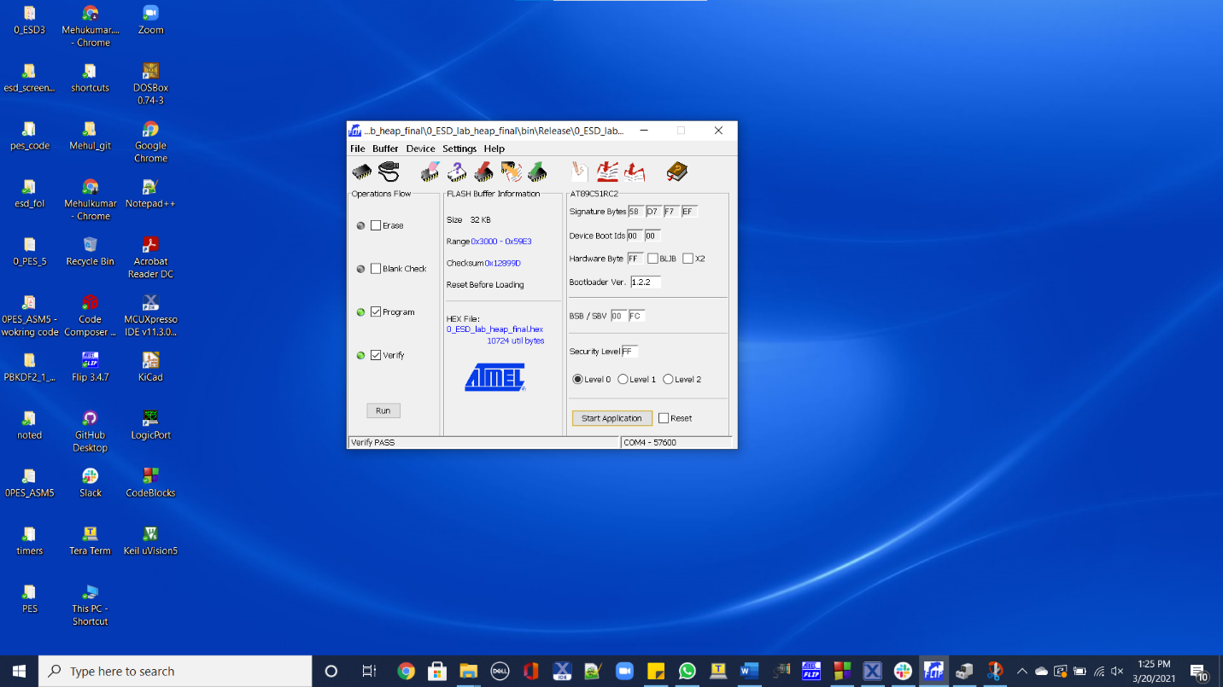

Paul man jump location j

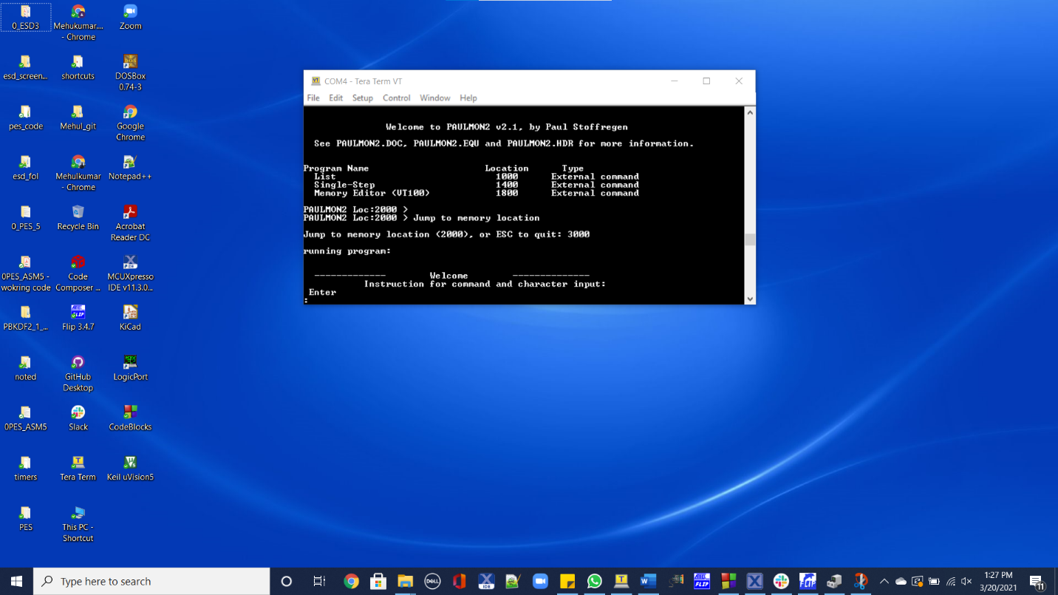

**Paulman Welcome msg**

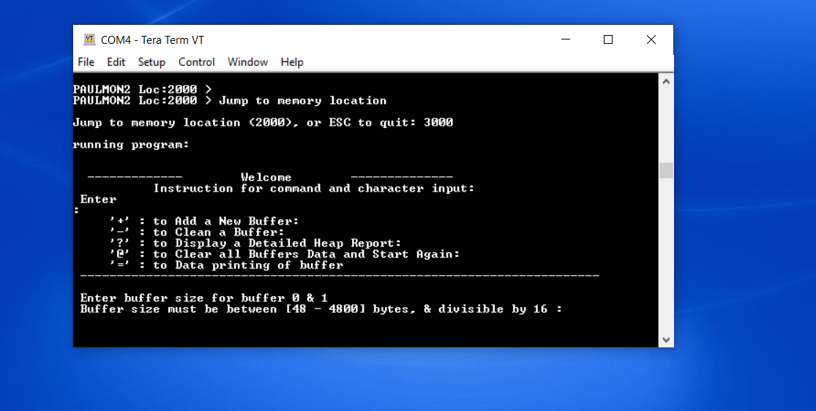

**Commands**

'+' : to Add a New Buffer:

'-' : to Clean a Buffer:

'?' : to Display a Detailed Heap Report:

'@' : to Clear all Buffers Data and Start Again:

'=' : to Data printing of buffer

small 'a'-'z' : for char i/p - to Store these Characters in Buffer 0:

if I press ‘*’ it will provide help

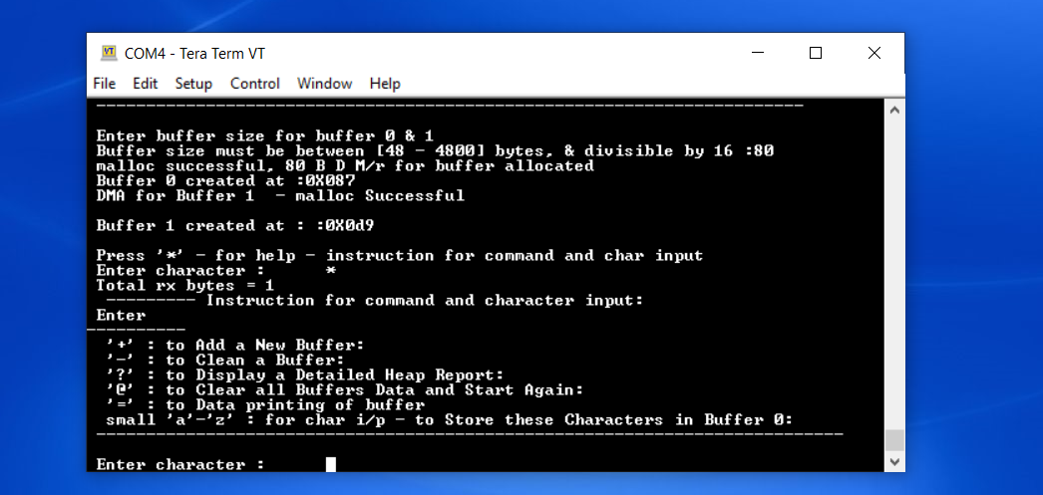

Entering buffer size

Succeful for 64(decimal byte 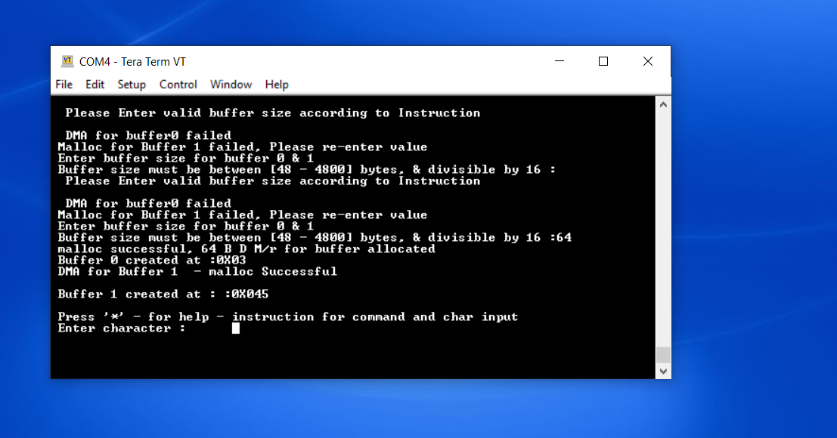

Entering buffer size

Succeful for 80(decimal) byte

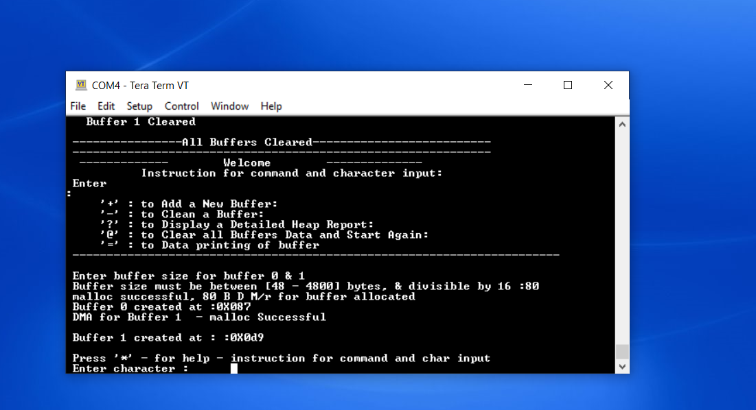

It wll try to allocate m/r for buffer only satisfy both condn

* Buffer size must be between [48 - 4800] bytes,
* & divisible by 16 :80

After that if malloc successful then only it will stat next operation

Here it will also allocate m/r for buffer 1 with same size and print

Buffer 0 created at :0X087

DMA for Buffer 1 - malloc Successful

Entering data – character --- only small chars accepted

‘a’ to ‘z’ only

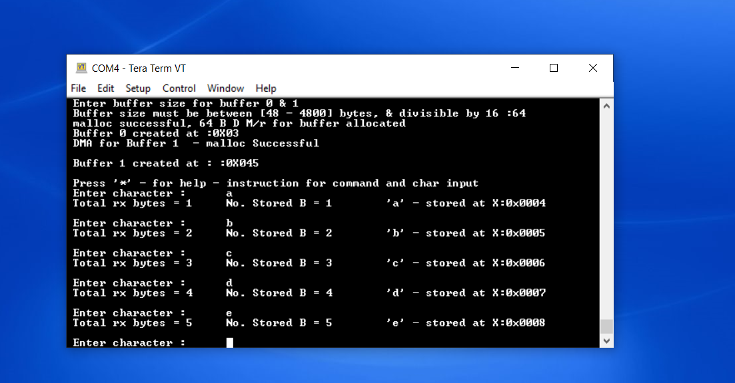

For caps – ‘A’ – ‘Z’ it will not allow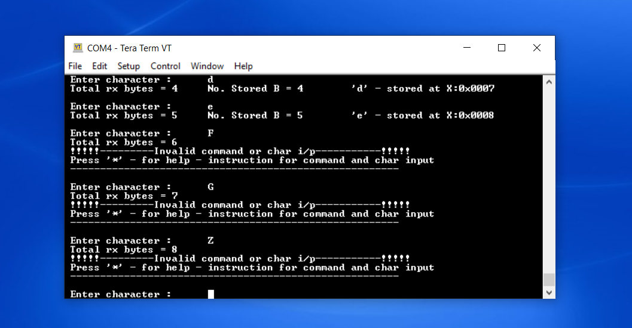

Heap report

From lab writeup

The program must keep count of how many total characters and how many storage characters are received. Every time the character '?' is received, the program must provide a report on the heap, including information about each buffer currently in the heap, including: buffer #, buffer start address, buffer end address, total allocated size of the buffer (in bytes), number of storage characters currently in that buffer, and number of free spaces remaining in that buffer. Note that the heap report will change as storage characters are stored in and emptied from buffer_0. The program must also report the total number of characters received since the last '?'. The C program must clearly report all these numbers on the terminal emulator screen, along with descriptive text. The program then must empty the buffer by transmitting all the characters which were stored in buffer_0, with a maximum of 64 ASCII characters displayed on each line of the screen. buffer_0 will then be empty. The quality of your user interface will be a factor in your grade.

If buffer_0 fills completely before a '?' command is received, any excess character subsequently received for that buffer is echoed out the serial port, but is not added to that buffer (it is discarded). Once the '?' command is received, then buffer_0 is emptied, as described above.

All in terms of (in bytes)

B_N : Buffer Number

St_addr: Buffer Start Address

E_Addr : Buffer End Address

B_Size : Buffer Size - Total allocated size of the buffer

N_StoC : Storage Characters - Number of storage characters currently in the buffer

N_FSpace:Free Space - number of free bytes remaining in the buffer

When I press ‘? ‘ it will generate heap report like this

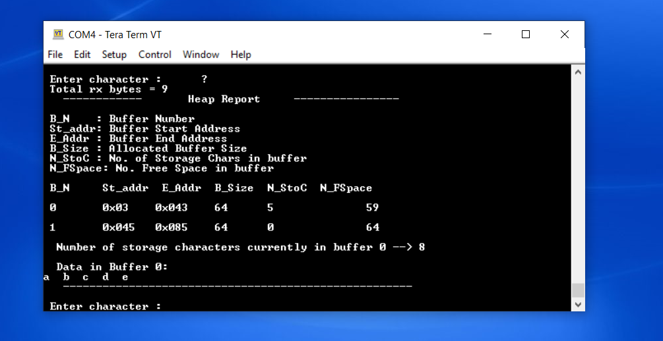

------------ Heap Report ----------------

B_N : Buffer Number

St_addr: Buffer Start Address

E_Addr : Buffer End Address

B_Size : Allocated Buffer Size

N_StoC : No. of Storage Chars in buffer

N_FSpace: No. Free Space in buffer

B_N St_addr E_Addr B_Size N_StoC N_FSpace

0 0x03 0x043 64 5 59

1 0x045 0x085 64 0 64

Number of storage characters currently in buffer 0 --> 8

Data in Buffer 0:

a b c d e

-----------------------------------------------------

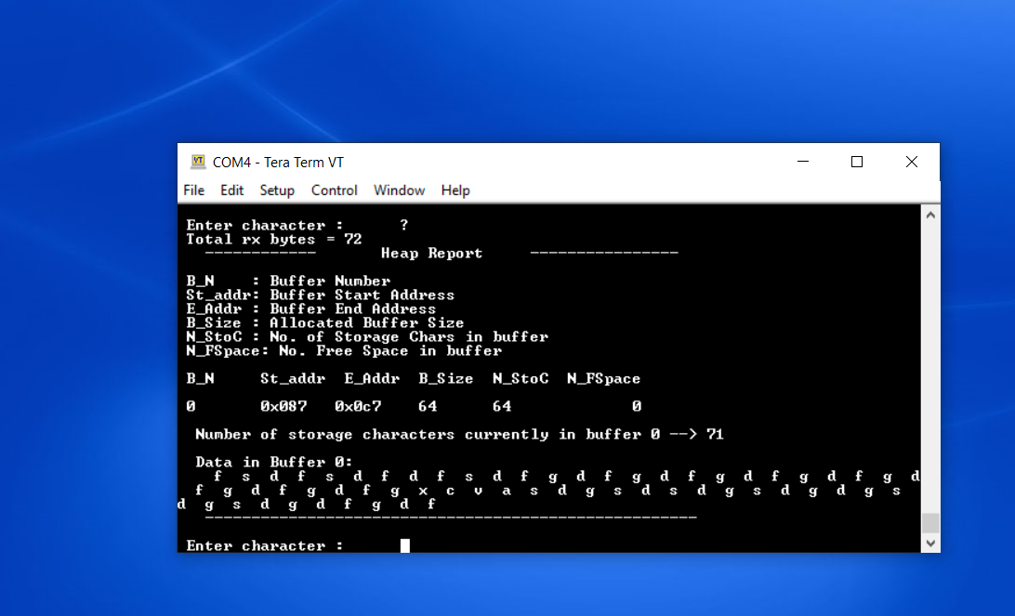

Heap report --- when I have enterd chars

We can see data in buffer 0



For ‘=’ command

From lab write up

If the '=' character is ever received, the program must display the current contents of buffer_0 in hex, **but must not empty the buffer** – the data will remain in the buffer until the buffer emptied in response to a ‘?’ command. Display the data on the PC screen in hexadecimal (not ASCII), with 16 bytes of data per line, in the following format (AAAA is address, DD is data):

**AAAA: DD DD DD DD DD DD DD DD DD DD DD DD DD DD DD DD**

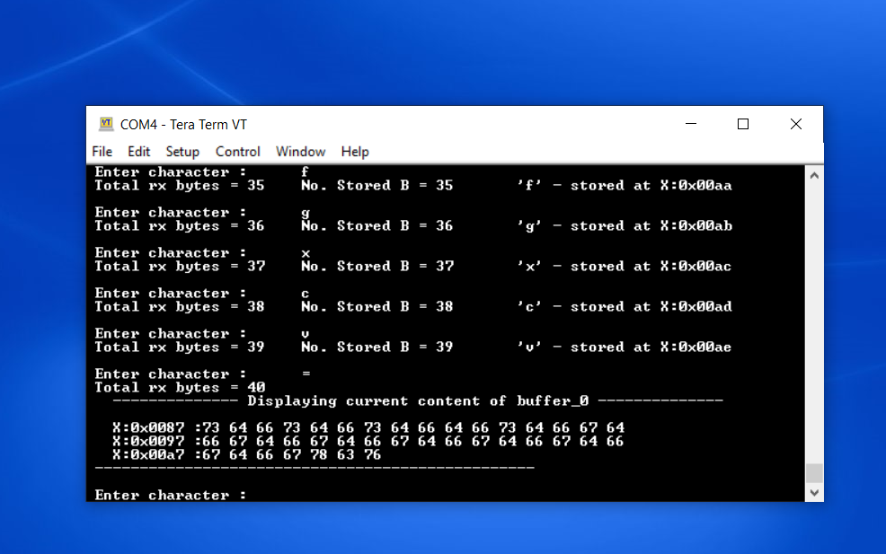

In heap report we can see

No of rx and storage chars

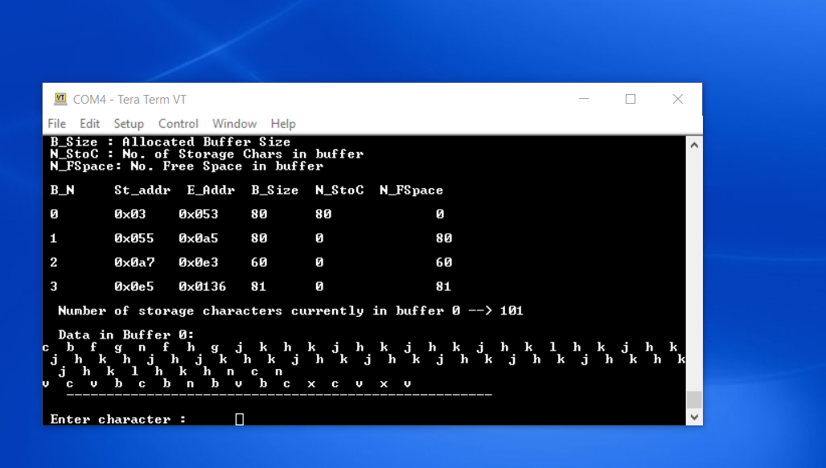

if I press ‘@’ then it will clear all buffers

And start from again – I am calling main from here

From lab writeup

If the '@' character is ever received, the program must immediately use the free() function to free the heap space being utilized by all current buffers that have been allocated. The program shall then start over from the beginning and ask the user to specify a new buffer size.

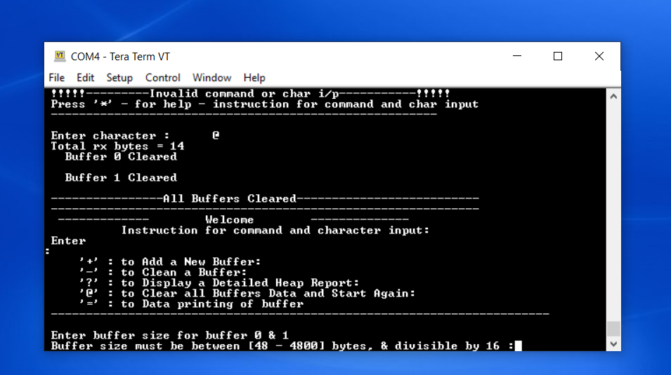

For = command

It will display current data in buffer 0



Buffer clearning - and @ command

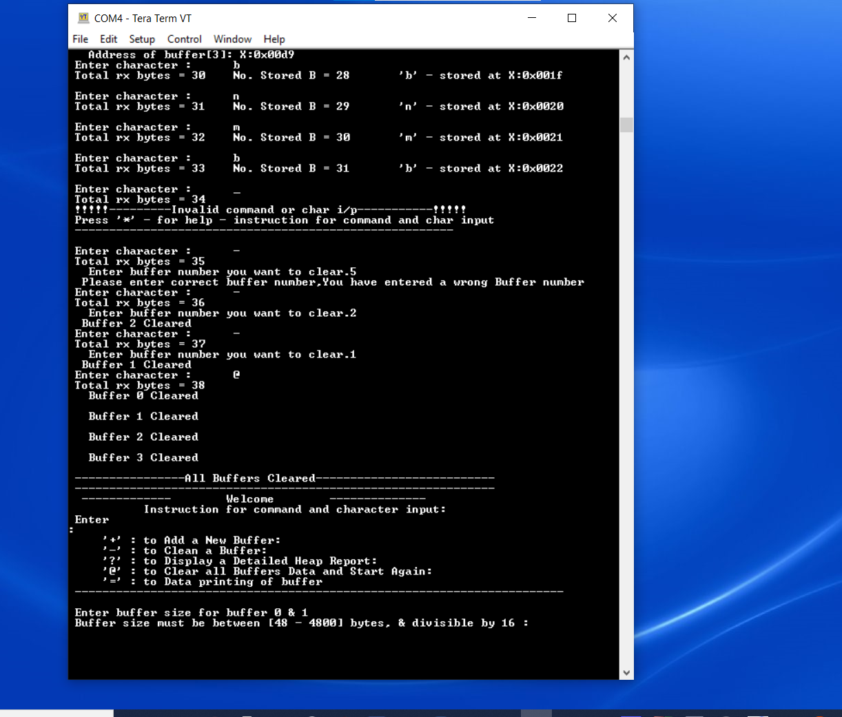

Virtual Address Debug port

0x8000h

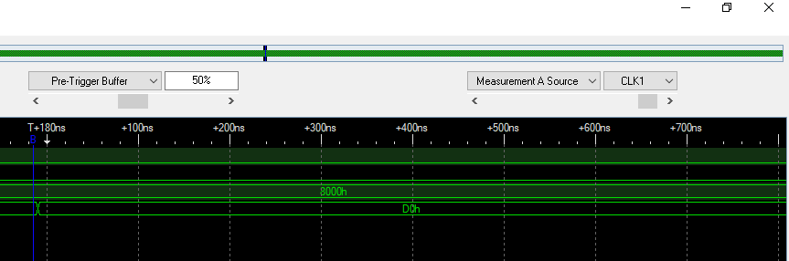

Code reference : professor lecture/ asmnt writeup

#define DEBUG 1

#ifdef DEBUG

#define DEBUGPORT(x) dataout((x));

#else

#define DEBUGPORT(x) // empty statement, nothing passed on from the preprocessor to the compiler

#endif

void dataout(uint8_t data)

{

uint8_t * ptr = NULL;

ptr = 0x8000; //get address to write at 0x8000 loc

* ptr = (data); //write data

}

MSP 432

Note: I have used Accessport software – UART terminal software in place of Teraterm –

- no difference – just like UI

1. Echo function is called on receiving input character on uart

- interrupt-driven TX and RX of characters

:: desinged UART interrupt function

2. PWM signal generation- used pin P2.4

starting duty cycle 55%

starting value of duty_cycle= 550

if receive 'P'/'p' on uart => print duty cycle

3. ADC temperature calculation using the MSP432 built-in temperature sensor.

if receive 'T'/'t' on uart => print temperature

- here initally set the flag for value to be seen

- for Celsius = = print in temperature value in Celsius

- for Fahrenheit = = print in temperature value in Fahrenheit

* If the switch at P1.4 is pressed - PWM duty cycle increases by 10%

* If the switch at P1.1 is pressed - PWM duty cycle decreases by 10%

* for switch is pressed

**User inputs keys/for UART**

T/t - to print temperature

c/C - to change to see temperature in Celcius

F/f - to change to see temperature in farenheit

p/P - to print PWM duty cycle in percentage

d/D - command to change PWM duty cycle using user input

- next enter value in 0.00-100.00 range for percentage duty cycle %

r/R - to start change PWM duty cycle based on change in temperature

- 10 % change in duty cycle at 0.5 celcius change in temperature

x/X - to stop change PWM duty cycle based on change in temperature

as temperature will not change much change celicus change gap to smaller value

or print log

if want to see change temp based change change value change from 0.5 to other value

in read_temperature() function ----

Print temperature c or F

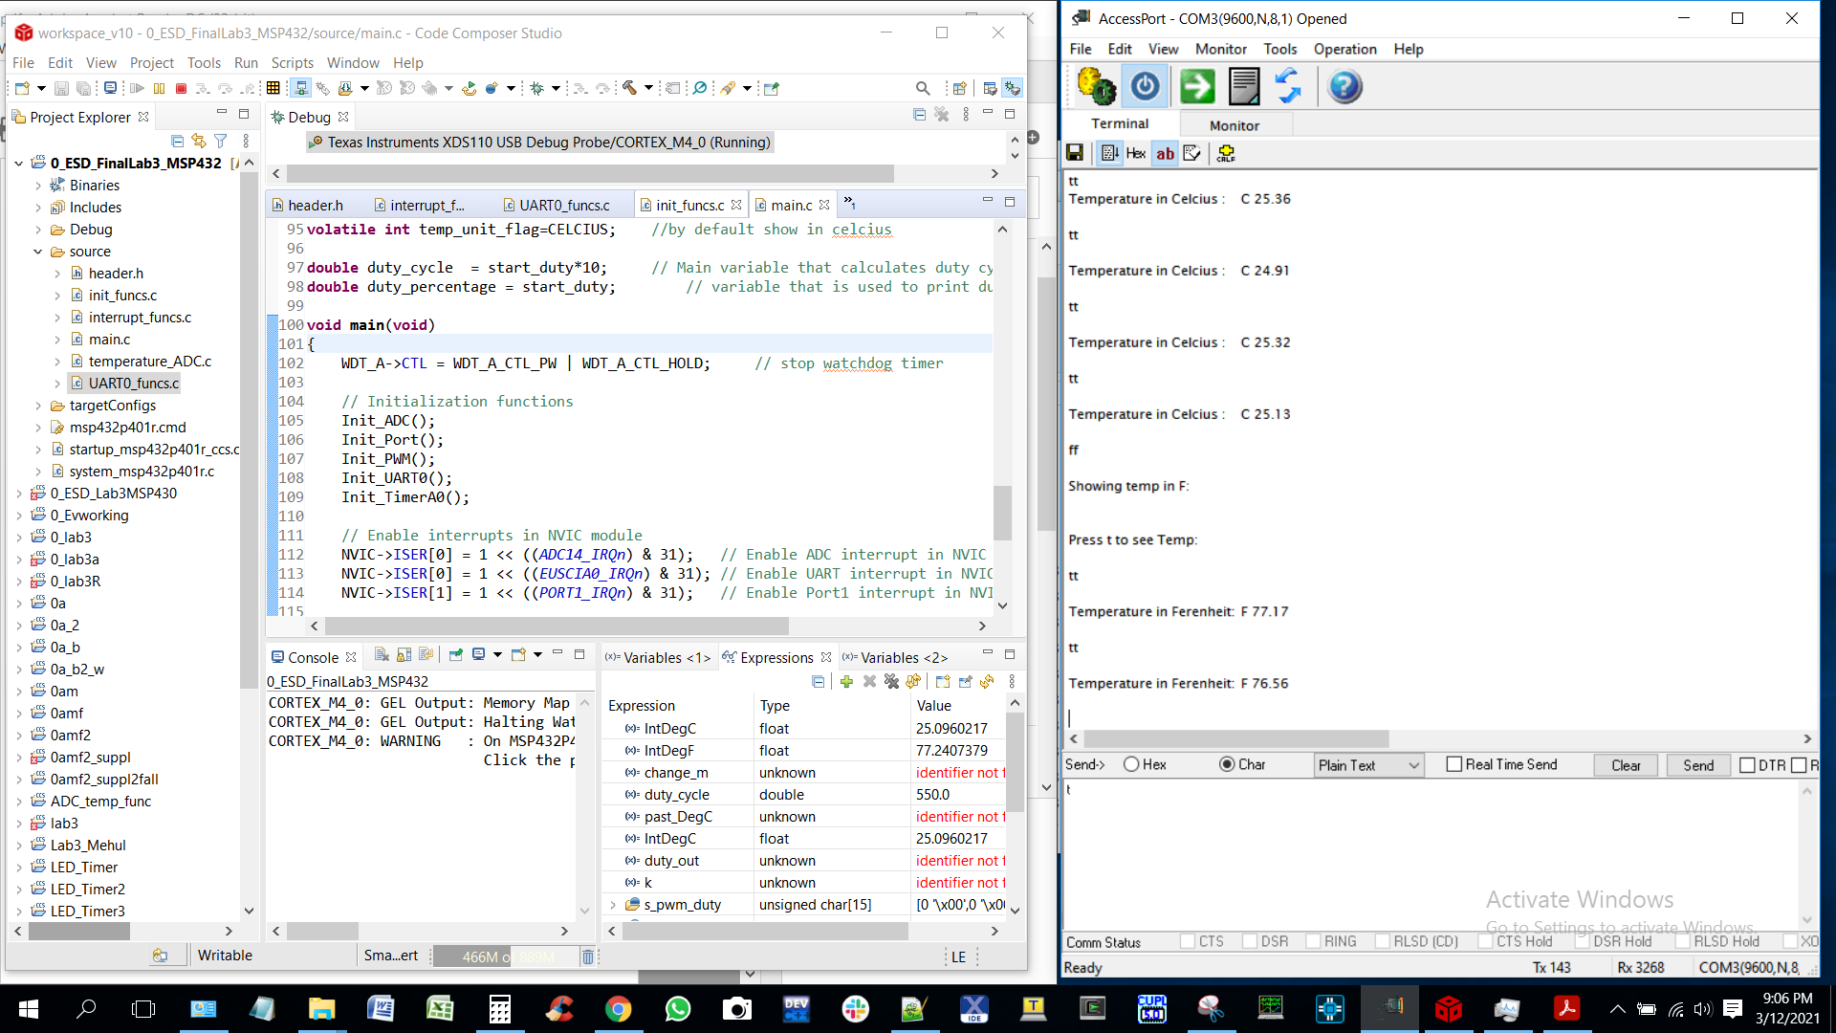

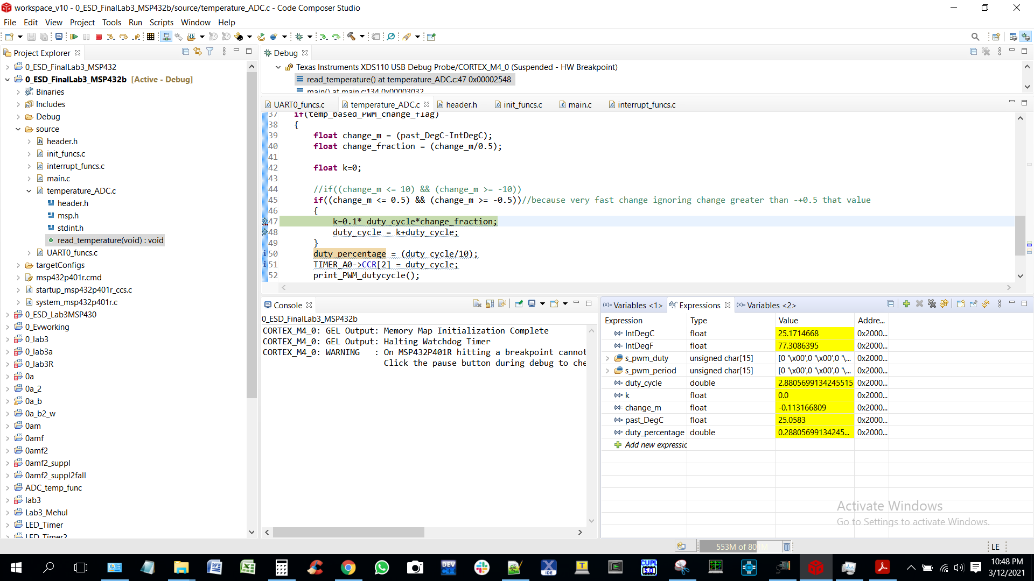

Changing PWM using temperature value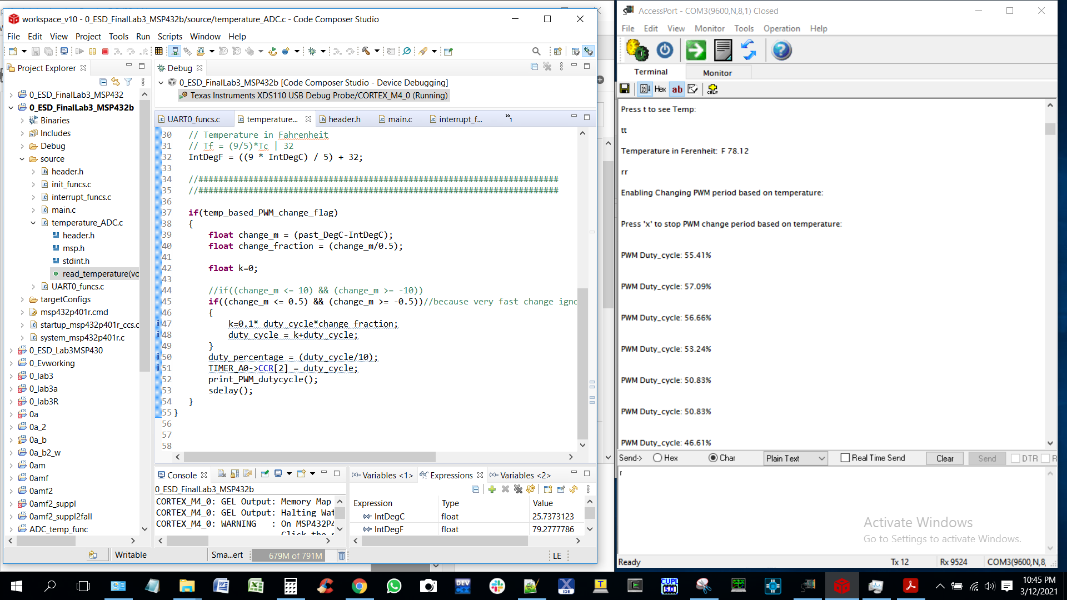

switch_press_pwm_duty_cycle2

changing PWM on switch press 

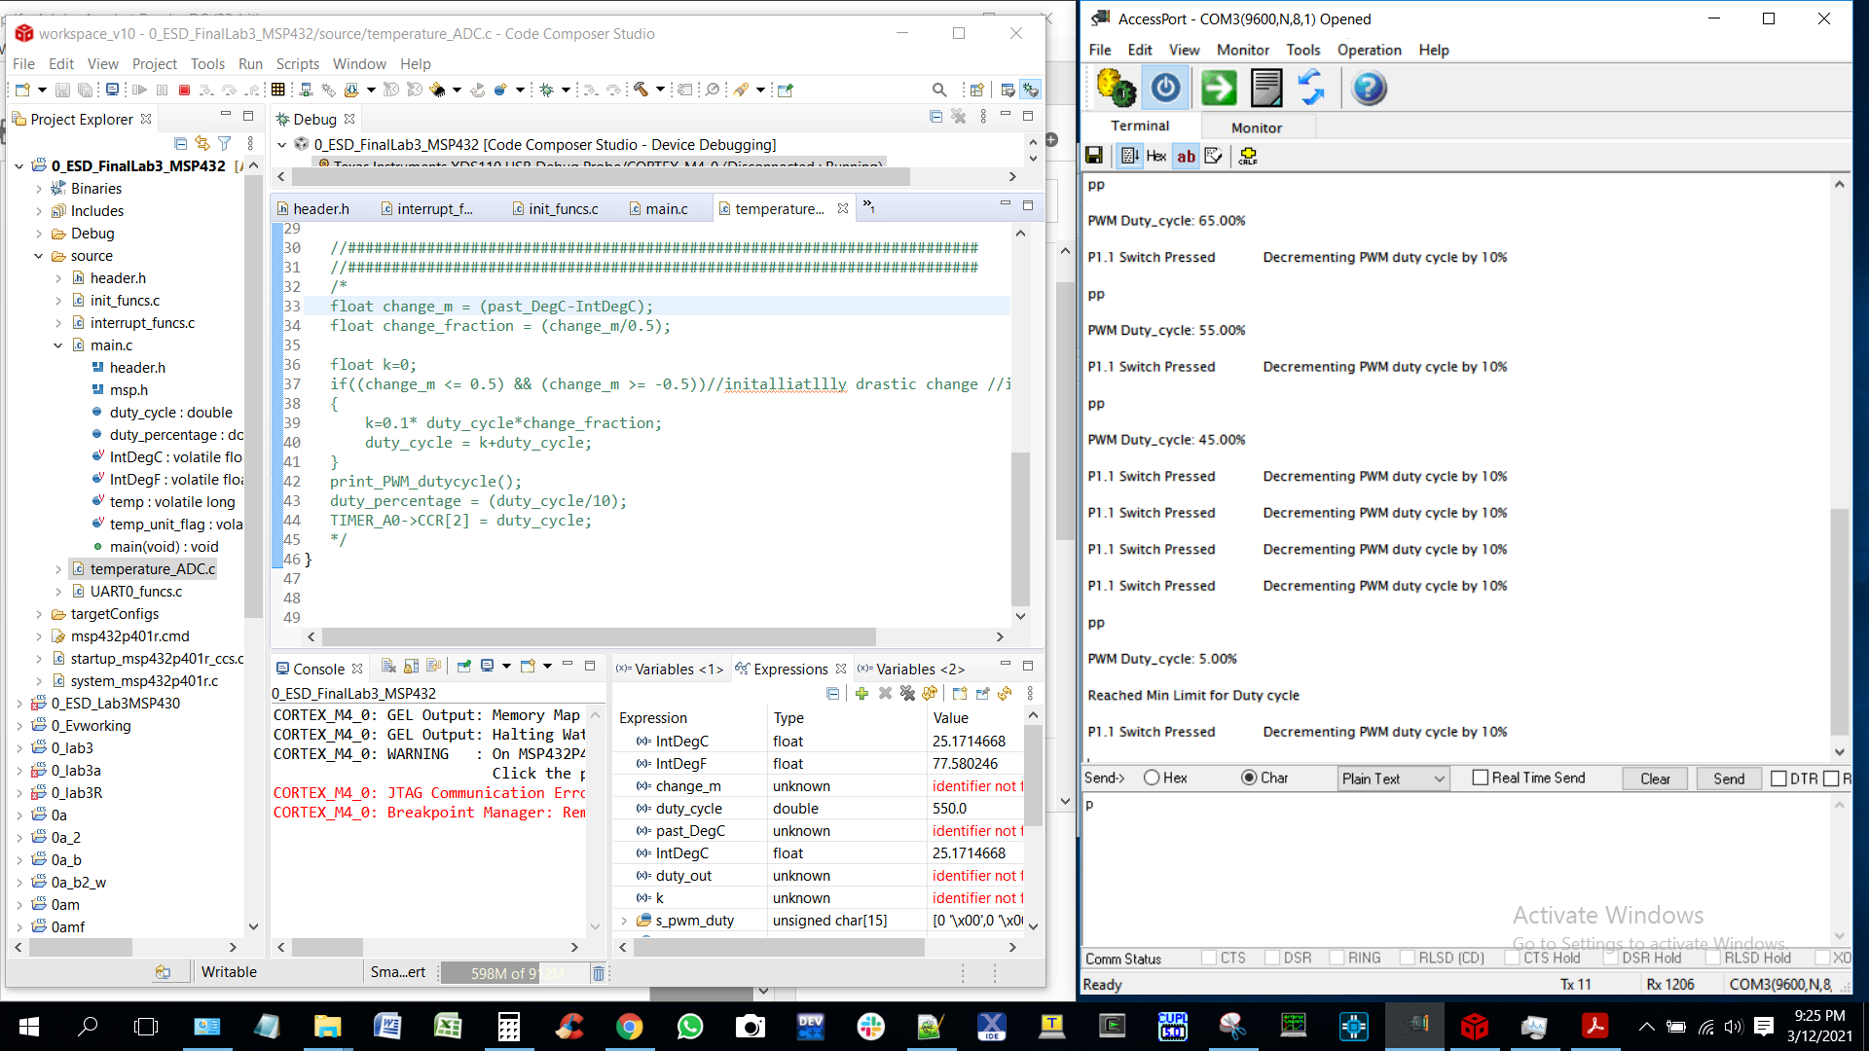

Duty cycle for PWM

5 %

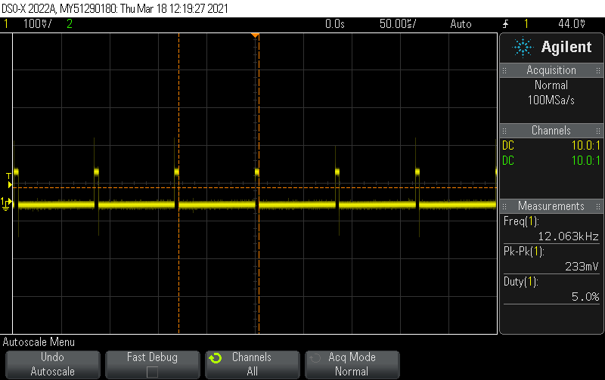

15%

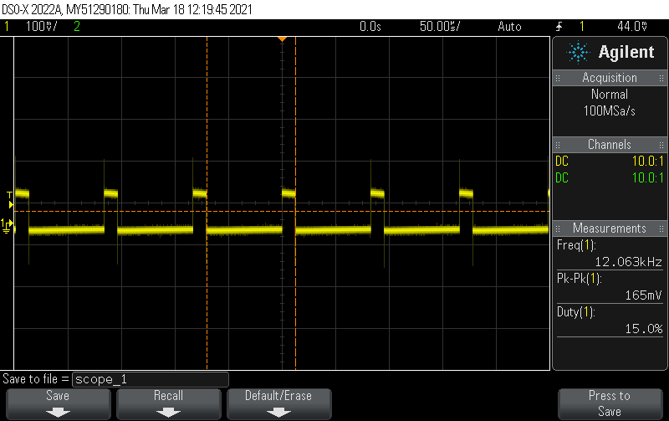

25

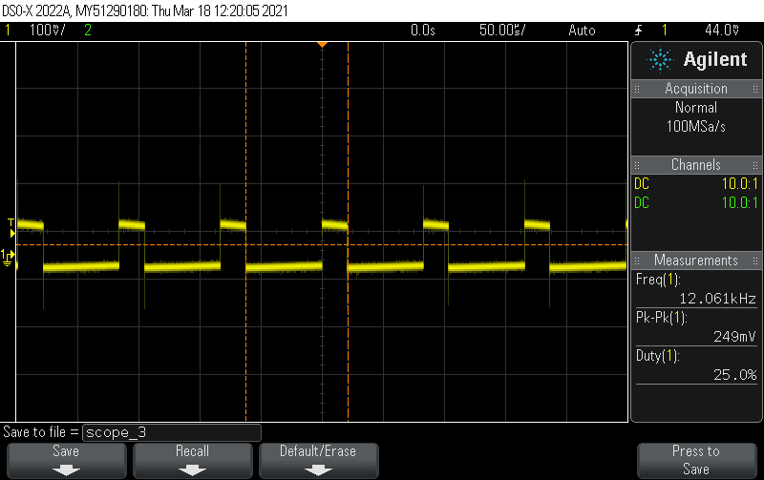

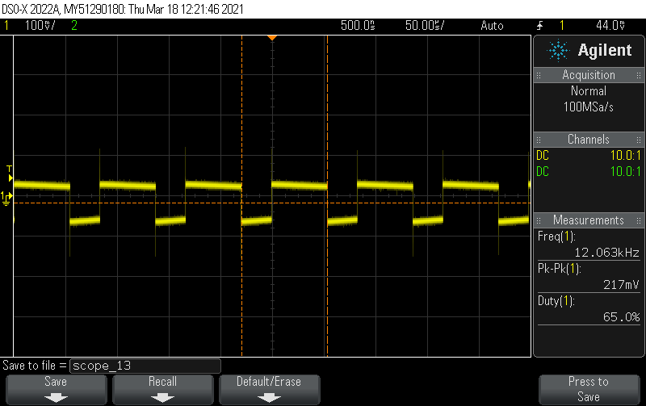

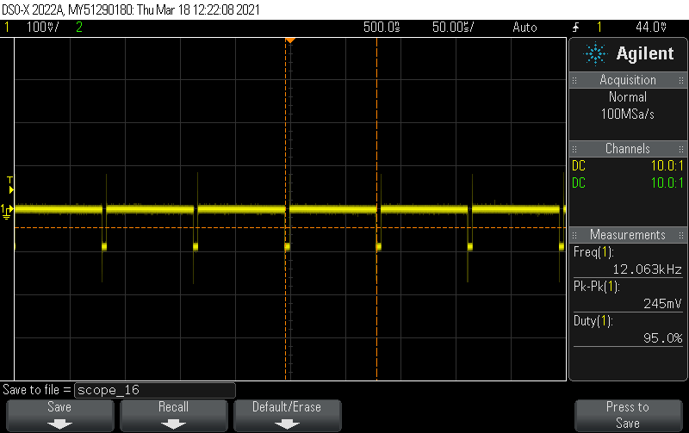

Setting pwm using d command

Set to 83 